Network Tetris (Beta Version 1.0)

Nishil Shah

Table Of Contents

Set-up.....................................................................................................pg. 3-5

Objective....................................................................................................pg.6

Controls.....................................................................................................pg. 6

Scoring......................................................................................................pg. 6

SET-UP
If you want to play a single-player game, then go to Part A.
If you want to play a multiplayer game and you will be the host, then go to Part B.
If you want to play a multiplayer game and you will be the client, then go to Part C.

Part A
Step 5: Please click on Tetris.bat and enjoy the game!

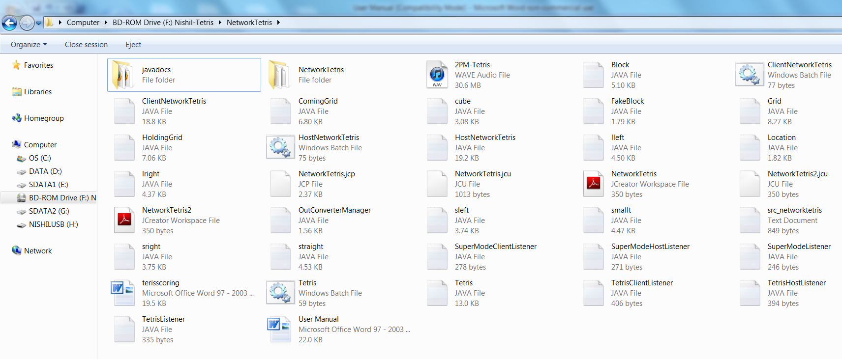

Part B
Step 5: Please click on HostNetworkTetris.bat

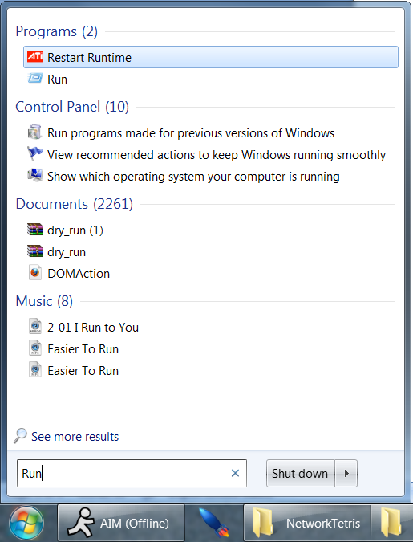
Step 6: Go back to the Start menu and search for a program called "Run". Click on it.

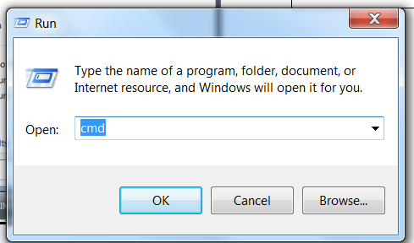
Step 7: Type in "cmd" and hit "OK"

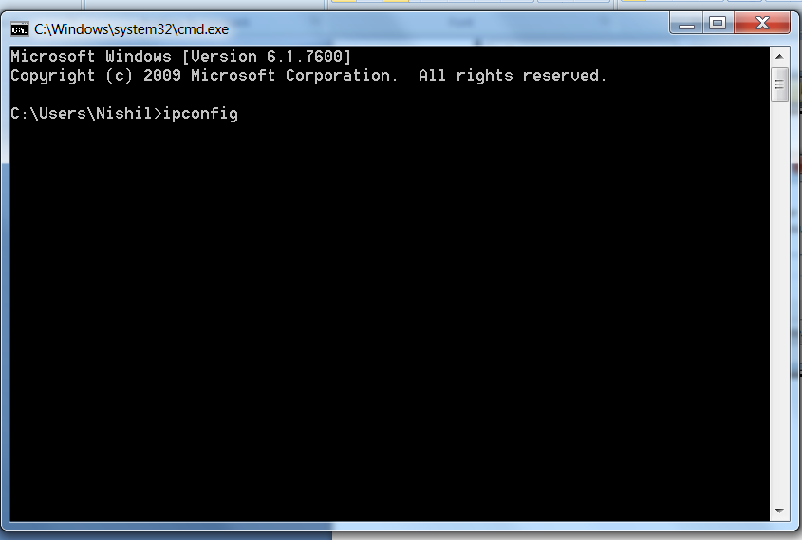
Step 8: Type in "ipconfig" and hit "Enter" on your keyboard.

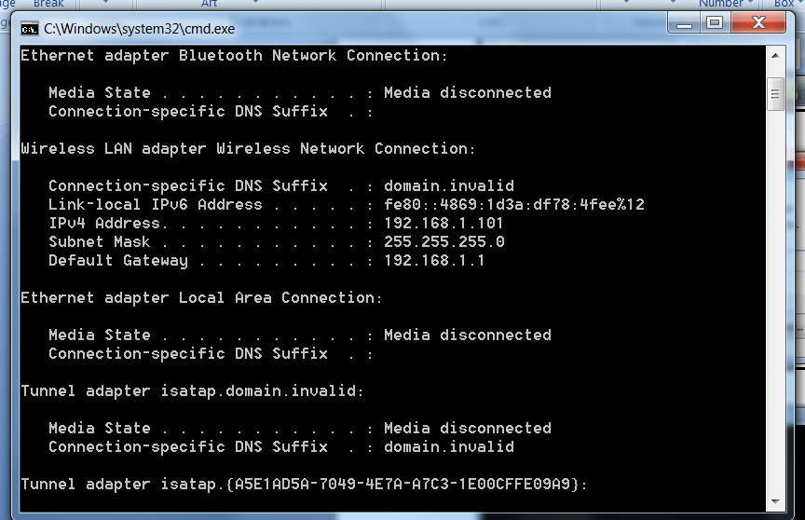
Step 9: Record your IPv4 or aka IP Address. For example, mine would be 192.168.1.101. Then, give this info to your friend that you are playing against. Then, go back to the game screen and wait for your friend.

Part C
Step 5: Please click on ClientNetworkTetris.bat

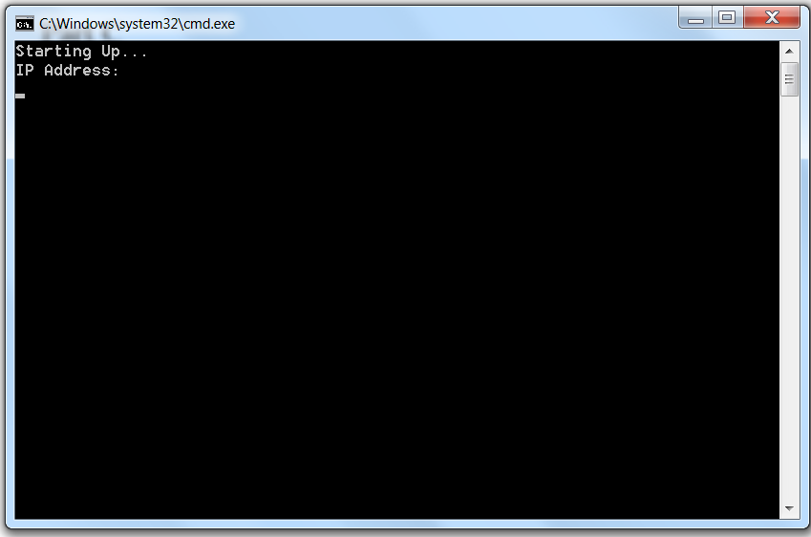
Step 6: Please enter the IP Address that your friend has given in you in order to connect to his or her computer. Have fun playing!
Objective
Stay alive as long as possible while scoring as many points as you can by empting the rows in the grid.
Controls
Left Arrow Key – Moves current piece left
Right Arrow Key – Moves current piece right
Down Arrow Key – Moves current piece down
Up Arrow Key – Rotates current piece
Space Bar – Moves current piece as far down as possible
C key – Exchanges piece with the holding grid
S key - Super-Mode Activation (Beta Version 1.0 only!)

Scoring
You receive points for using the down arrow key, and even more for the Space bar key. If you fill up more than one row at the same time, you can receive even more points. If you get multiple Tetrises (4 lines erased at a time), you can score BIG! As of now, scored cannot be saved.

